GUIDE

1. Click and edit the text of the following (Lastname, Firstname, Station, Employee No., Position, Contact, under the other information box, and Name of the employee)
2. Insert the Profile Picture and QR Code of employee number go to <https://www.the-qrcode-generator.com/>
3. Print



**ATM Size**

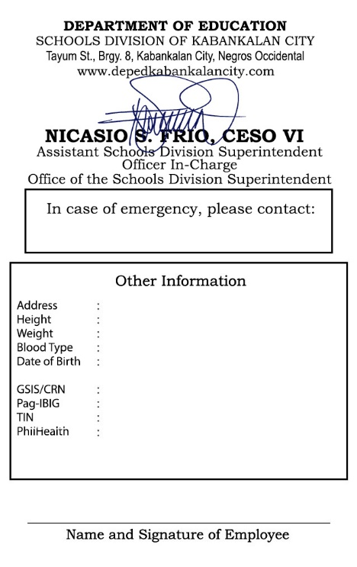

EMPLOYEE NO. 1234567

**LASTNAME,**

**FIRSTNAME MI**

**STATION/OFFICE**

**POSITION**



**REGION VI**

**SDO-Kabankalan City**



**JUANA DELA CRUZ**

**Tayum St., Brgy. 8, Kab. City**

**5’6”**

**42 Kg**

**O+**

**January 1, 1990**

**XXXXXXXXXXX**

**XXXXXXXXXXX**

**XXXXXXXXXXX**



**Juan Dela Cruz / 09xx-xxx-xxxx**

🡪click to insert image for QR Code



**XXXXXXXXXXX**

🡫

Click to insert image of Profile Picture

**CSC Size**



EMPLOYEE NO. 1234567

**REGION VI**

**SDO-Kabankalan City**

**LASTNAME,**

**FIRSTNAME MI**

**STATION/OFFICE**

**POSITION**

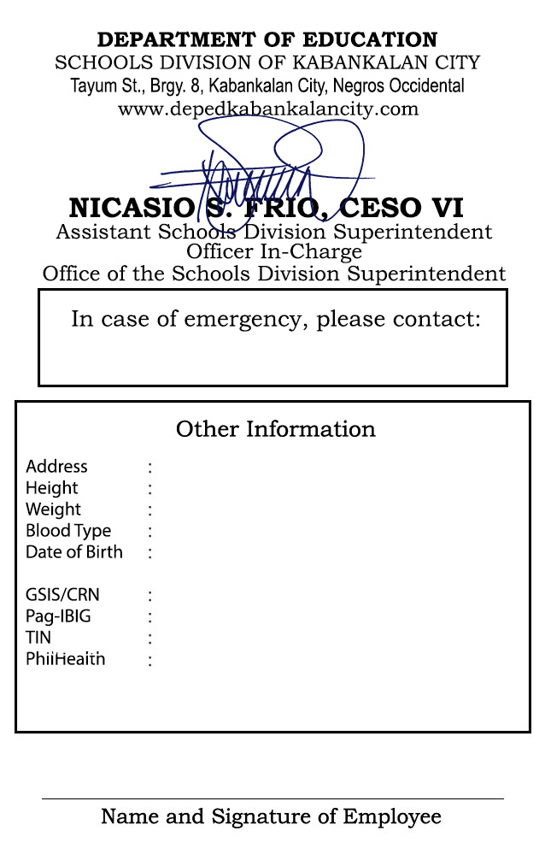

**Juan Dela Cruz / 09xx-xxx-xxxx**

**Tayum St., Brgy. 8, Kab. City**

**5’6”**

**42 Kg**

**O+**

**January 1, 1990**

**XXXXXXXXXXX**

**XXXXXXXXXXX**



**JUANA DELA CRUZ**

**XXXXXXXXXXX**

**XXXXXXXXXXX**