GUIDE

1. This is an editable template.
2. Click and edit the text of the following (Lastname, Firstname, Station, Employee No., Position, Contact, under the other information box, and Name of the employee) see next page.
3. To insert the QR Code of employee number go to <https://www.the-qrcode-generator.com/>, choose Free Text.
4. Inset Profile Picture
5. Print



Go to Next Page**ATM Size**

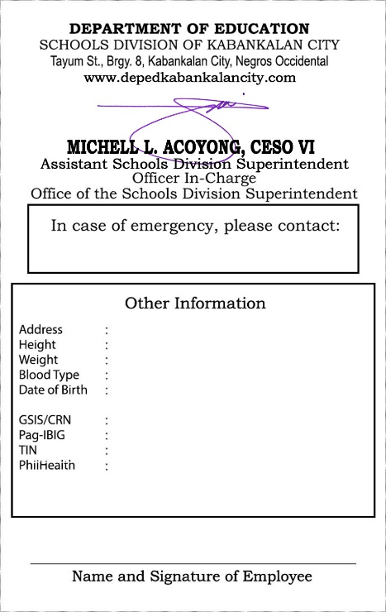

EMPLOYEE NO. 1234567

**LASTNAME,**

**FIRSTNAME MI**

**STATION/OFFICE**

**POSITION**



**REGION VI**

**SDO-Kabankalan City**



**JUANA DELA CRUZ**

**Tayum St., Brgy. 8, Kab. City**

**5’6”**

**42 Kg**

**O+**

**January 1, 1990**

**XXXXXXXXXXX**

**XXXXXXXXXXX**

**XXXXXXXXXXX**



**Juan Dela Cruz / 09xx-xxx-xxxx**

🡪click to insert image for QR Code



**XXXXXXXXXXX**

🡫

Click to insert image of Profile Picture

**CSC Size (Back-to-back)**



EMPLOYEE NO. 1234567

**REGION VI**

**SDO-Kabankalan City**

**LASTNAME,**

**FIRSTNAME MI**

**STATION/OFFICE**

**POSITION**







EMPLOYEE NO. 1234567

**REGION VI**

**SDO-Kabankalan City**

**LASTNAME,**

**FIRSTNAME MI**

**STATION/OFFICE**

**POSITION**



🡫

Click to insert image of QR Code

🡫

Click to insert image of QR Code



↑Click to insert image of Profile Picture

↑Click to insert image of Profile Picture